INTERNSHIP REPORT

Tourism Guidelines:

Exploring Top Countries and Their Major Visiting Centers

Student Name: Helana Francis
Register Number: pnaysc019
Program: Bsc.computer science
College: Prajyoti niketan collage pudukad
Internship Organization: ziuke imfo tech
Internship Duration: 15-8-2025 to 29-12-2025
Total Hours Completed: 60 hrs
Industry Supervisor(s):Sruthi sunil

Acknowledgement
I would like to express my sincere gratitude to my internship supervisor for providing me with the opportunity to work on the project titled “Tourism Guidelines: Exploring Top Countries and Their Major Visiting Centers.” Their constant guidance, encouragement, and valuable feedback played a crucial role in the successful completion of this internship.
I am also thankful to the management and staff of the host organization for offering a supportive learning environment and providing access to essential resources. I extend my heartfelt thanks to my college faculty and internal supervisor for their academic guidance and continuous support throughout the internship period.
Finally, I would like to thank my family and friends for their encouragement and motivation during this learning journey.

Executive Summary
This internship was undertaken at Ziuke Info Tech, a private internship provider company, with a project titled “Tourism Guidelines: Exploring Top Countries and Their Major Visiting Centers.” The primary objective of the internship was to design and develop a web-based application that provides structured tourism information using modern web development technologies.
The project was developed using Python with the Django framework, and Visual Studio Code (VS Code) was used as the Integrated Development Environment (IDE). The application focuses on presenting tourism guidelines, popular destinations, and major visiting centers of the top 10 tourist countries in an organized and user-friendly manner.
During the internship, I gained hands-on experience in Django project setup, URL routing, models, views, templates, and database integration. I also worked on organizing tourism data, creating dynamic web pages, and implementing basic user interface components. This internship helped bridge the gap between academic knowledge and real-world application development, while enhancing my skills in backend web development, problem-solving, and project implementation.
Internship Certificate

Table of Contents
- Organization Profile
- Internship Overview
- Internship Experience
- Learning Reflection
- Appendices

Organization Profile
Ziuke Info Tech is a private internship provider company that focuses on offering practical, skill-oriented training to students in the field of information technology. The organization provides internships in areas such as web development, Python programming, Django framework, data handling, and software application development.
Ziuke Info Tech aims to enhance students’ employability by combining theoretical concepts with real-time project development. The company follows a project-based learning approach, allowing interns to work on real-world problems using industry-relevant tools and technologies. Through structured guidance and mentorship, Ziuke Info Tech helps students gain hands-on experience in software development, debugging, and deployment practices.
The organization emphasizes learning through practice, encouraging interns to develop complete applications while following professional development standards.

Internship Overview
Internship Duration
The internship was conducted for a period of 10 days, during which a total of 60 hours were completed as per the internship requirements.
Objectives of the Internship
- To gain practical experience in Python and Django web development
- To develop a tourism-based web application
- To explore tourism guidelines and major visiting centers of top countries
- To apply academic concepts in a real-world project environment
- To enhance problem-solving and programming skills
Project Overview
The internship project involved the development of a Django-based tourism guidelines application that provides information about the top tourist countries and their major attractions. The application was designed to display tourism details in a structured and easily accessible format.
Tools and Technologies Used
- Programming Language: Python
- Framework: Django
- IDE: Visual Studio Code (VS Code)
- Frontend Technologies: HTML, CSS
- Database: SQLite (Django default database)

Internship Experience

Summary of Tasks
- Researching top tourist countries based on visitor statistics
- Identifying major tourist attractions and cultural landmarks
- Studying entry requirements, visas, and travel guidelines
- Preparing country-wise tourism summaries
- Organizing data into structured reports

Key Contributions
- Compiled accurate tourism data
- Created structured tourism guidelines
- Enhanced destination comparison analysis

Challenges Faced
- Managing large volumes of information
- Ensuring data accuracy
- Understanding cultural differences

Personal Learning and Observations
This internship improved my research capability, global awareness, and understanding of tourism diversity. I learned how tourism plays a vital role in economic and cultural development.

Learning Reflection

Academic Knowledge vs Practical Experience
While academic learning provided theoretical knowledge about tourism management, this internship offered practical exposure to real-world tourism planning, destination analysis, and guideline formulation.

Role of Internal Supervisor
The internal supervisor provided constant guidance, clarified doubts, reviewed progress, and ensured that the internship aligned with academic objectives. Their support was instrumental in completing the project successfully.

Appendices
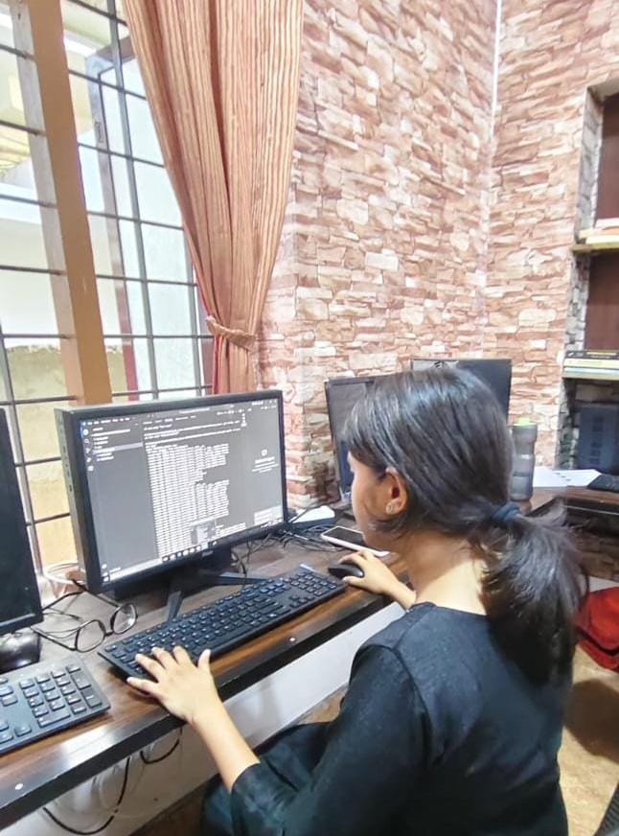
Workbook Summary
The internship workbook maintained during the internship period contains a detailed record of daily and weekly activities performed throughout the project duration. The workbook documents the progress of the project titled “Tourism Guidelines: Exploring Top Countries and Their Major Visiting Centers”, developed using Python and Django.
During the initial phase, the workbook records activities related to understanding project requirements, setting up the Django development environment, and studying tourism data sources. In the subsequent phase, it documents tasks such as creating Django models, views, URL configurations, and templates, along with organizing tourism information for different countries.
The final phase of the workbook includes testing, debugging, and refining the web application, as well as documenting the learning outcomes and challenges faced. Overall, the workbook reflects continuous learning, practical exposure to Django-based web development, and systematic completion of internship tasks.
Worksheet
click here

